**A genome metabolic network model of new sulfur-oxidizing bacterium *Acidithiobacillus* sp.AMEEHan**

**Peng Wu1,2,4†, Qianqian Yuan3,4†, Yifan Han2,4†, Wei Zhao2,4†, Tingting Cheng1,2,4, Xiaoping Liao3,4, Lu Wang1,2,4, Jingyi Cai3,4, Qianqian He, Ying Guo2,4, Xiaoxia Zhang2,4, Fuping Lu1, Jingjing Wang2,4*, Hongwu Ma3,4*, Zhiyong Huang2,4\***

1College of Bioengineering, Tianjin University of Science and Technology, Tianjin, China 2Tianjin Key Laboratory for Industrial Biological Systems and Bioprocessing Engineering, Tianjin Institute of Industrial Biotechnology, Chinese Academy of Sciences, Tianjin, China

3National Technology Innovation Center of Synthetic Biology, Tianjin, China

4Core Facility, Tianjin Institute of Industrial Biotechnology, Chinese Academy of Sciences, Tianjin, China

† These authors contributed equally to this work.

**\* Correspondence:**Hongwu Ma  
[ma_hw@tib.cas.cn](mailto:ma_hw@tib.cas.cn)

Jingjing Wang

[wang_jj@tib.cas.cn](mailto:wang_jj@tib.cas.cn)

Zhiyong huang  
[huang_zy@tib.cas.cn](mailto:huang_zy@tib.cas.cn)

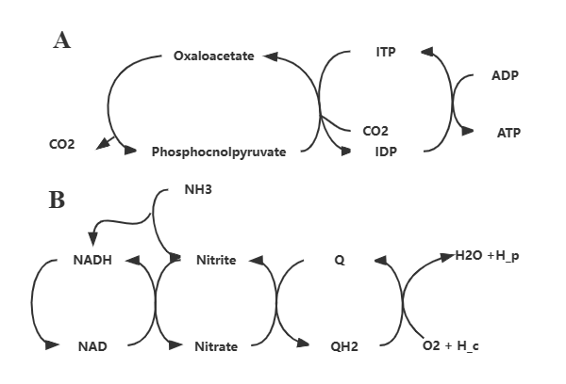

**Supplementary Figure S1.** Two type errors in Model_01. **(A)** The energy-generation cycle leading to ATP inifite generation. **(B)** The proton pump cycle leading to ATP infinite generation.

**Supplementary Figure S2. Comparison of *in vivo* and *in silico* growth rates of *Acidithiobacillus* sp. AMEEHan.**

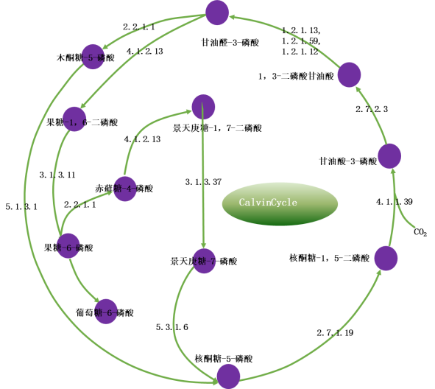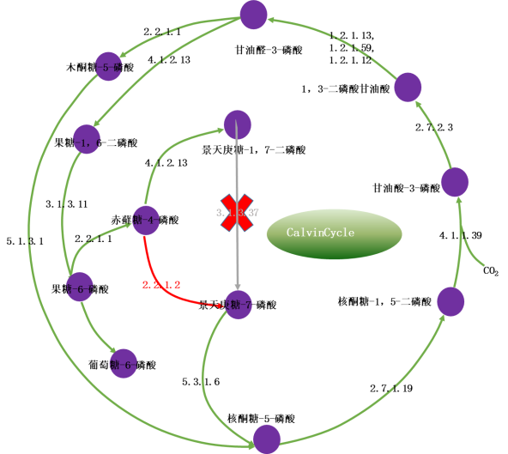

**Supplementary Figure S3. Differences between real Calvin and variant Calvin cycles.**

The left diagram shows the actual Calvin cycle carbon sequestration metabolic pathway, and the right diagram shows the Calvin carbon sequestration metabolic pathway of AC bacteria variant, its Calvin cycle lacks the ability to catalyze the reaction of Sedum heptonulose 1,7-diphosphate into Sedum heptonulose-7-phosphate during the regeneration of RuBP in the third step of the Calvin cycle, but it can converting erythrose 4-phosphate into Sedum heptonulose-7-phosphate, which enables the Calvin cycle to proceed.